2019-2020 Yearbook Staff Application
Please complete and return to Yearbook Advisor Mrs. Arcori by Friday May 3rd.

Contact Information
Name: |  | Phone:
Grade: |  | Email:

Counselor:

Extracurricular Activities & Availability
Sports & Other Clubs You’re In: | Other Activities Outside of School:
1. | 1.
2. | 2.
3. | 3.
4. | 4.
5. | 5.
Yearbook meets after school at 2:30 every week usually Thursdays. Can you attend these meetings?

Why Yearbook?
What are three skills you will bring to yearbook? | What three things do you want to learn in yearbook?
1. | 1.
2. | 2.
3. | 3.
Why do you want to join yearbook?
What’s one thing about the current yearbook that you would improve? Or page ideas for this year’s yearbook.
On a scale from 1 to 10, where 10 is “I breathe yearbook” and 1 is “Eh,” how committed are you to yearbook? Circle the one that applies.
1 2 3 4 5 6 7 8 9 10

List any programs you are knowledgeable with? (Photoshop, e-design, picture editing, Ribbet)

List qualities you possess that would make you an excellent member of our WMHS Yearbook staff.

Yearbook Staff T-Shirt Design Proposal
For a creative exercise, please design a t-shirt that we could print so that the yearbook staff can wear it with pride and help promote the yearbook. Be sure to include/label with colors and design effects.
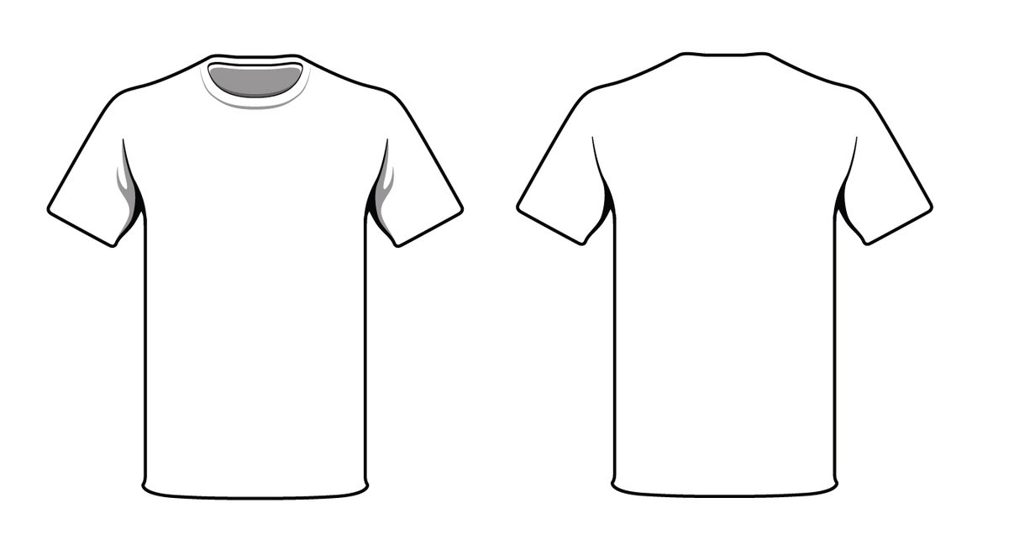

TEACHER RECOMMENDATION
FOR YEARBOOK APPLICATION

________________________________: you have been selected as a reference for

___________________________________________________________________.
I am asking you to evaluate this person as a student and on their writing ability in preparing for this year’s WMHS Yearbook staff. Please rank this student in the areas below on a scale of 1(strongly disagree) to 5 (strongly agree) – feel free to add comments if you would like. These will be kept confidential. Please return to my mailbox by Friday March 2nd. Additionally, there is space below each criterion and at the bottom for comments.
~Thanks for your help! Kelli Arcori

INDEPENDENCE 1 2 3 4 5
Is self-motivated, sets high standards, takes initiative, does not need constant direction

MATURITY 1 2 3 4 5
Is responsible, is able to handle high-stress situations, can balance fun and hard work, is trustworthy even without direct supervision

COLLABORATION 1 2 3 4 5
Is cooperative, has a pleasant attitude, works well with peers, is respectful of authority

PERSONALITY 1 2 3 4 5
Shows school spirit, is outgoing

WRITING 1 2 3 4 5
Is creative and original.

Consistently uses correct grammar and/or spelling
1 2 3 4 5

Check the statement that best describes your attitude towards this student:
I have strong reservations about recommending this student.
I feel that this student may be difficult to work with after school, but has potential.
I believe this student would be a good fit for the yearbook club.
Sign this student up now!

Please place this form in my mailbox (Arcori). Thank you again!

Teacher Signature:____________________________________________________________
Comments:

